Period: Sunday, May 24, 2026 - Saturday, May 30, 2026

KPIs
Total Consumption: 411 kWh
Operating Days: 3
Generator Share of Energy: 50%
Peak Load: 20 kW

Summary
During the week of 24 to 30 May 2026, the ABMF site consumed 411 kWh. Activity was confined to the three working days in the period because of the Wednesday and Thursday public holidays. Monday, Tuesday, and Friday together accounted for about 94% of consumption, so the large share of standby and no-power time reflects the operating schedule rather than any supply interruption.
‘Generator 1’ supplied roughly half of the total energy despite running on a smaller share of the hours than the grid. Its higher average load in Figure 6 (about 11 kW against the grid's 4 kW) is consistent with the generator carrying heavier demand when it runs, which is what allows it to account for half the energy in fewer hours. Friday was the most generator-dependent day, with the generator providing 97 of its 127 kWh (Figure 3).
The clearest operational issue is generator loading. Throughout the period the generator ran at or below 30% of capacity and never reached the 40 to 80% efficient band marked in Figure 7. As a general matter, sustained light loading of a diesel generator lowers fuel efficiency and raises long-term maintenance risk, so this is worth addressing through right-sizing or load consolidation.
On power quality, voltage stayed close to 230 V on both sources, with the grid more variable than the generator (Figure 8). Frequency ranged from about 49.5 to 51.5 Hz, with the widest swings during generator operation (Figure 9). Power factor was consistently low (0.44 on the grid and 0.47 on the generator) and did not improve at higher load (Figure 11), which suggests a structurally reactive load base rather than a light-load effect. Current unbalance readings near 200% correspond to single-phase operation and warrant follow-up. Total harmonic distortion remains under investigation, with the Phase A and B values currently unreliable, so it is not yet visualised.

Operating Overview
The distribution reflects the bank's operating schedule. The site actively drew power on only three of the seven days, so the combined standby and no-power share (about 58%) corresponds to the weekend and the Wednesday and Thursday public holidays rather than to supply interruption. During the week, the grid was the primary source (31% of the period) with Generator 1 providing backup (11%).
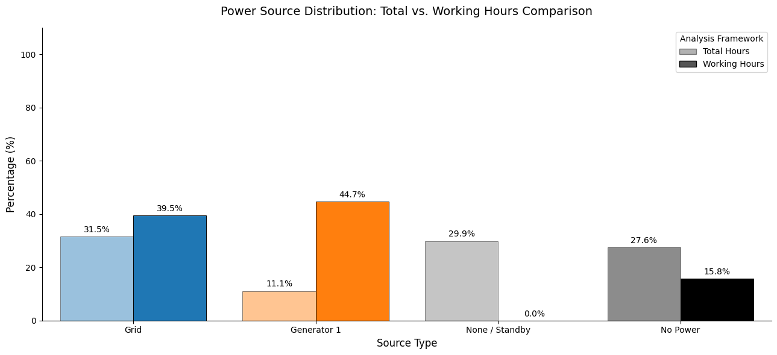
Figure 1: Power source distribution

Energy Consumption
Generator 1 supplied roughly half of the 411 kWh consumed over the period despite running on a smaller share of the hours than the grid.
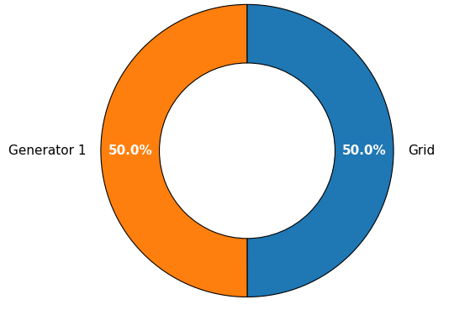
Figure 2: Total system consumption by active assets
Consumption is concentrated on the three working days, with Monday (135 kWh), Tuesday (126 kWh), and Friday (127 kWh) together accounting for roughly 94% of the week's energy. Wednesday (12 kWh) and Saturday (10 kWh) show only minimal background load, while Thursday and Sunday were effectively idle. Friday is the most generator-dependent day, with Generator 1 providing 97 of its 127 kWh.
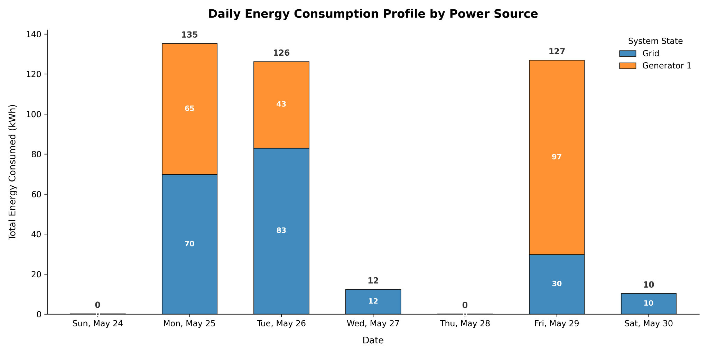
Figure 3: Daily energy consumption profile by power source

Load
Figure 4a confirms the three-day operating pattern, with demand rising to between 15 and 20 kW during business hours and falling close to zero outside them. The colouring shows the grid carrying the earlier part of each active day and Generator 1 taking over during specific blocks, some of which coincide with the highest load readings.
Across the three working days, load lifts off the overnight baseline at around 05:40 to 06:00, climbs quickly, and reaches a first peak near 08:00 to 08:30. It stays elevated through the day and tails off in the late afternoon, returning toward baseline by about 17:30 to 18:00, with a smaller residual draw into the evening. This points to an active-load window of roughly 06:00 to 18:00, with core operations between about 08:00 and 17:00, and the pre-08:00 rise and post-17:00 tail consistent with morning startup and evening wind-down.
A small persistent baseline of about 1 kW is visible overnight and on closed days, consistent with always-on equipment such as security, networking, or refrigeration. Also, Friday had no power from roughly 09:00 to 13:15, after which the generator took over.
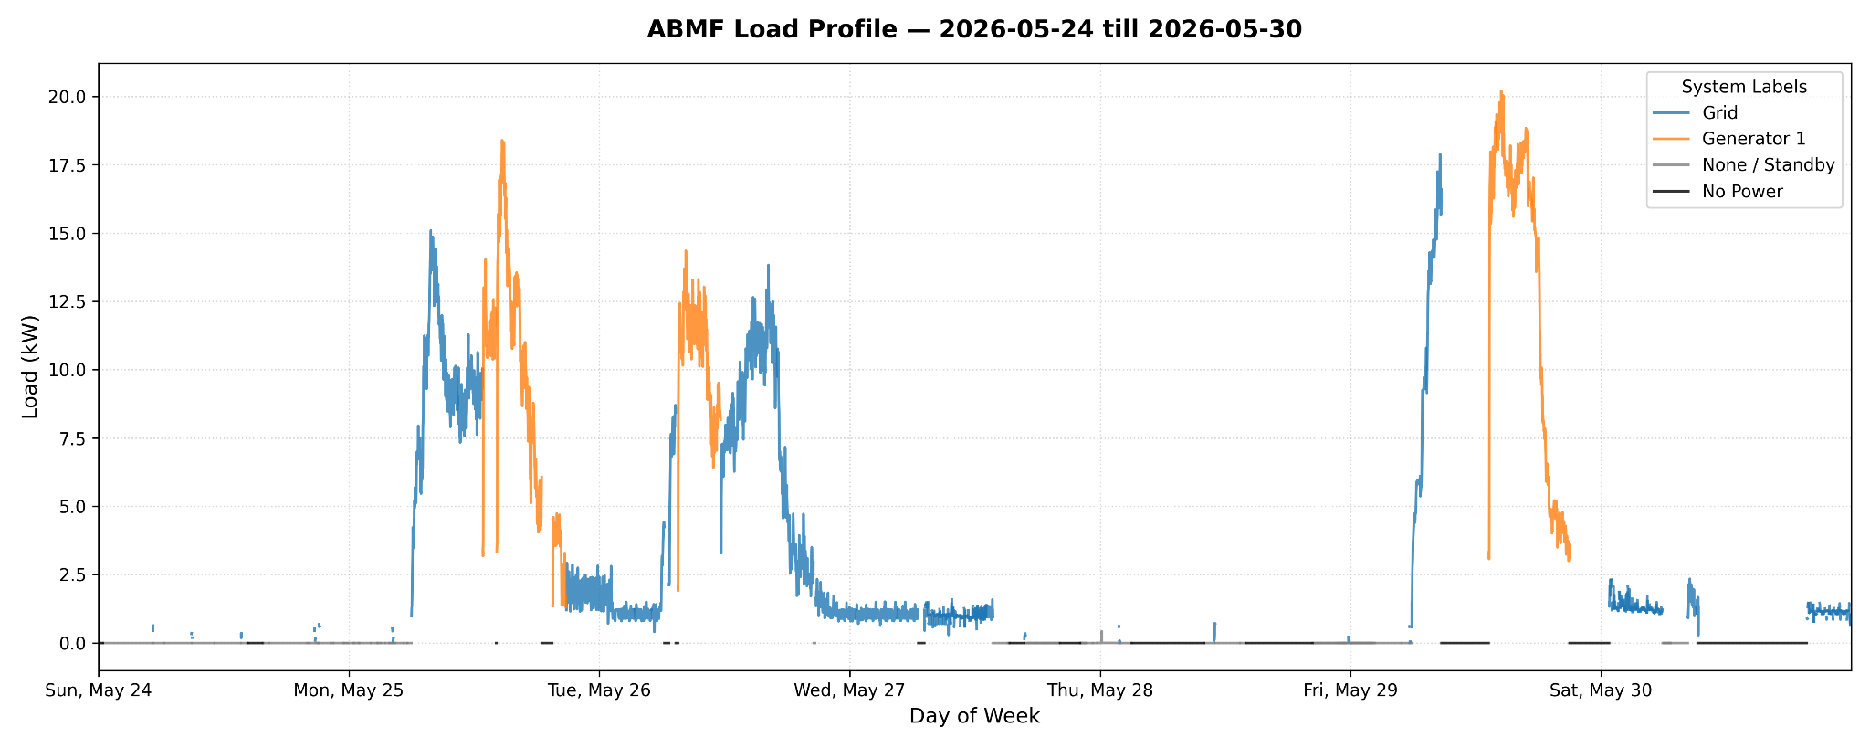
Figure 4a: Load profile across the week
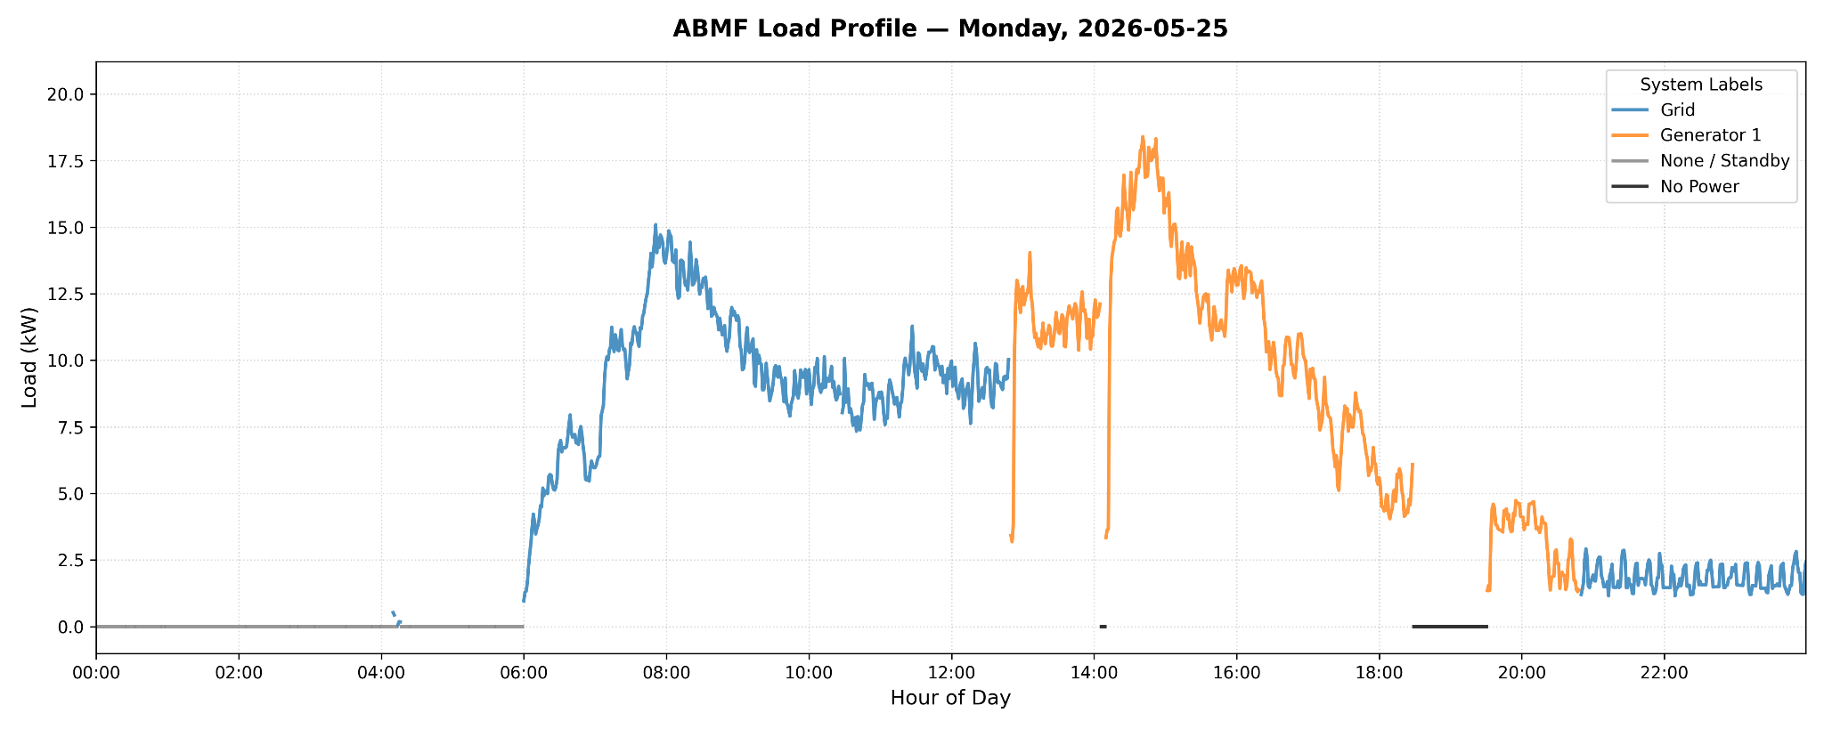Figure 4b: Monday load profile
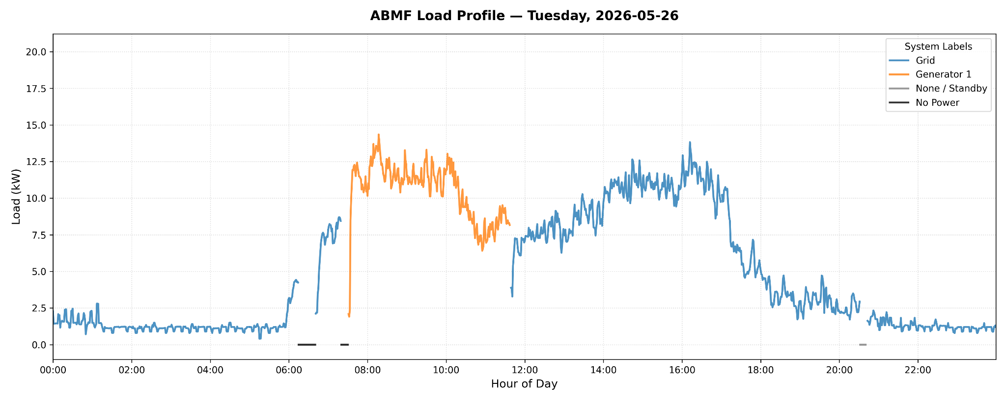Figure 4c: Tuesday load profile
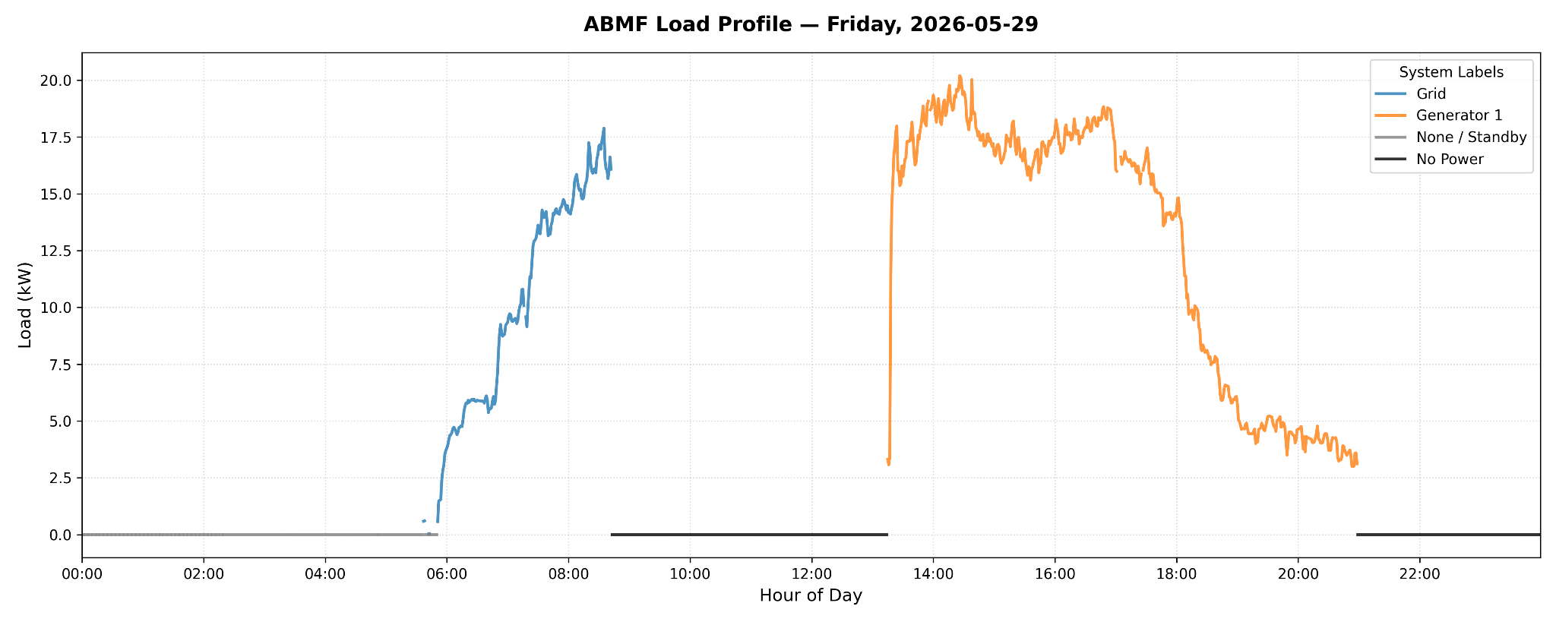
Figure 4d: Friday load profile
Activity concentrates in the Monday, Tuesday, and Friday daytime hours, while the blank cells on the remaining days indicate no recorded load, consistent with the closure schedule.
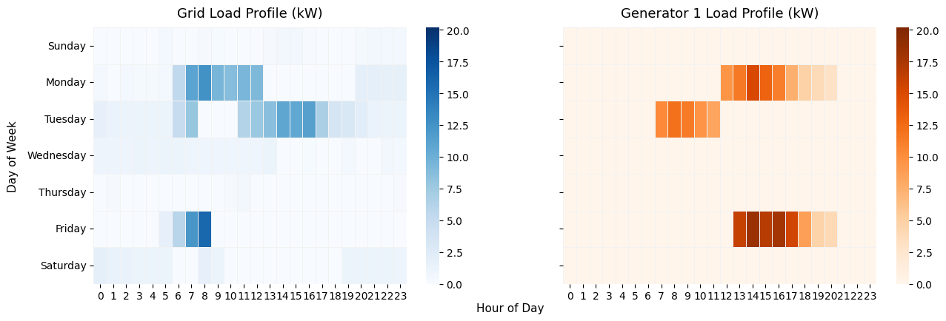
Figure 5: Weekly load heatmap (grid vs. generator 1)

Generator 1 averaged 11 kW with a 20 kW peak, while the grid averaged 4 kW with an 18 kW peak. The higher generator average suggests the generator operated at a heavier load than the grid when it ran.
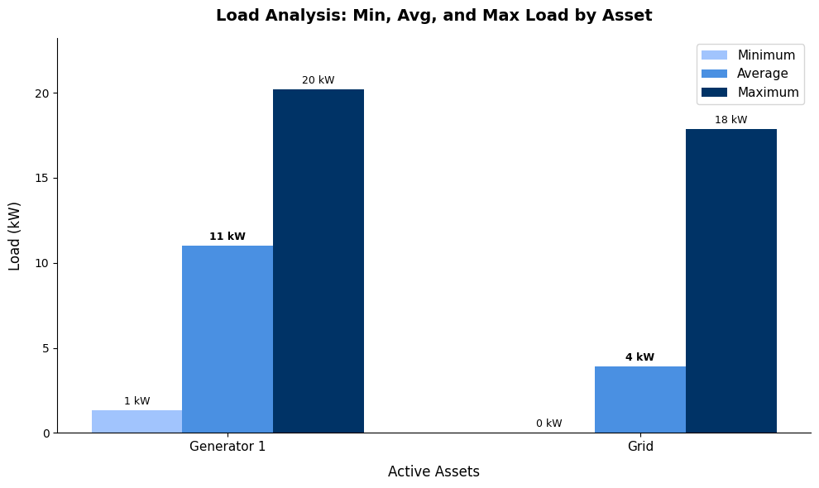
Figure 6: Load analysis: min, avg, and max load by asset

Generator Load Utilization
All recorded generator operations sat at or below 30% of capacity, entirely outside the 40 to 80% efficient band. Sustained light loading of a diesel generator lowers fuel efficiency and promotes wet-stacking and carbon build-up, which raises maintenance risk over time. Right-sizing the unit or consolidating load while it runs would address this.
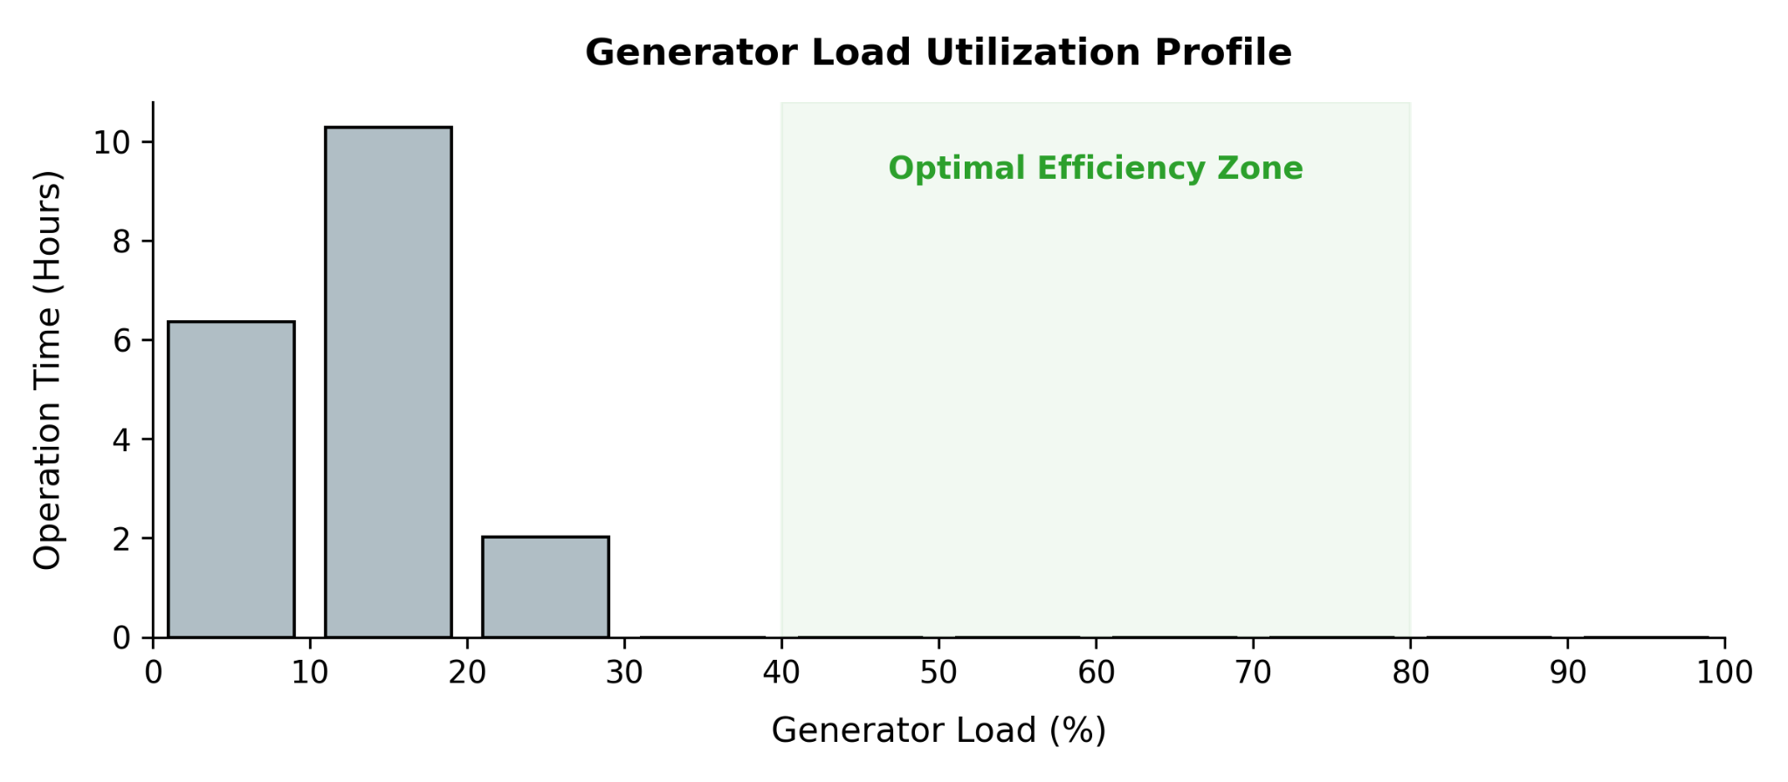
Figure 7: Generator load utilization profile

Power Quality

Voltage
Both sources held close to a nominal of about 230 V. Grid voltage was more dispersed, roughly 226 to 250 V, while Generator 1 stayed within a tighter 228 to 234 V band.
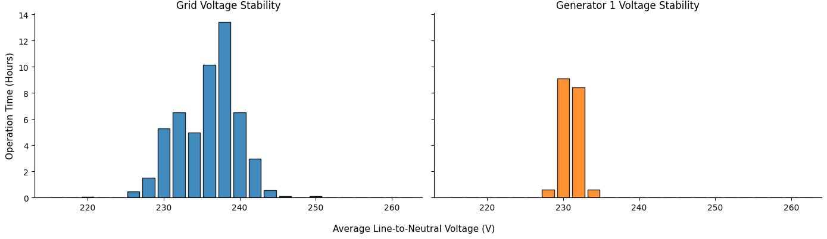
Figure 8: Weekly voltage distribution profile

Frequency
Frequency varied between about 49.5 and 51.5 Hz across the period. The widest excursions, above 51 Hz, occurred during Generator 1 operation, indicating looser frequency regulation on the generator than on the grid.
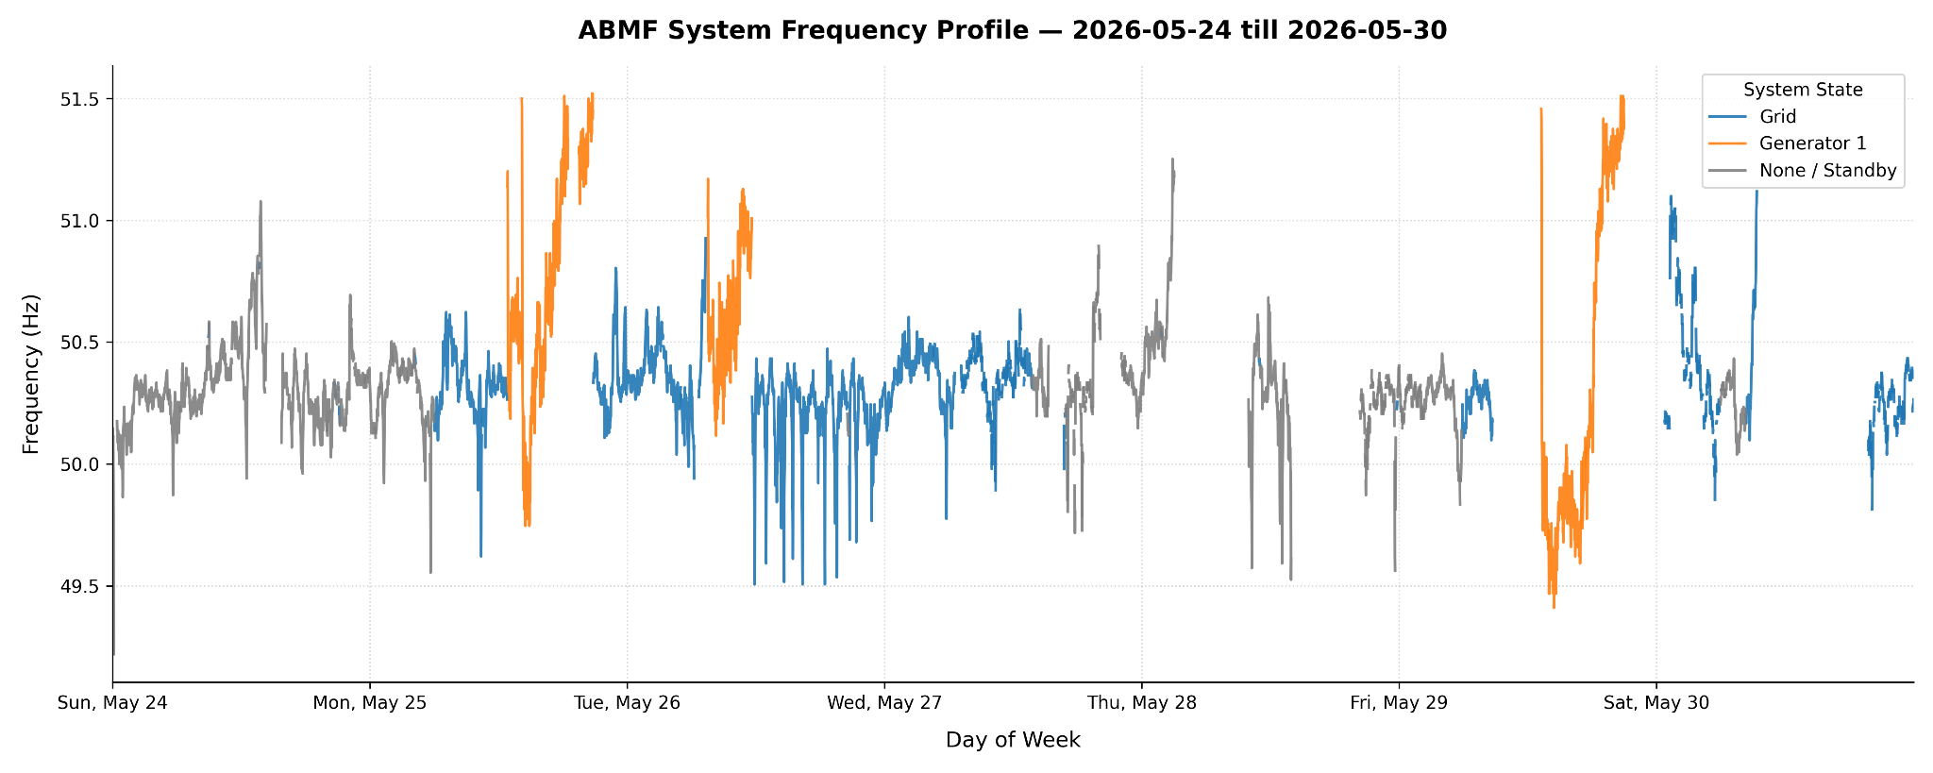
Figure 9: Frequency profile

Power Factor
Both sources operated at low power factor, averaging 0.44 on the grid and 0.47 on Generator 1, well below the 0.9 value expected. This points to a heavily reactive load base and possible exposure to utility power-factor penalties.
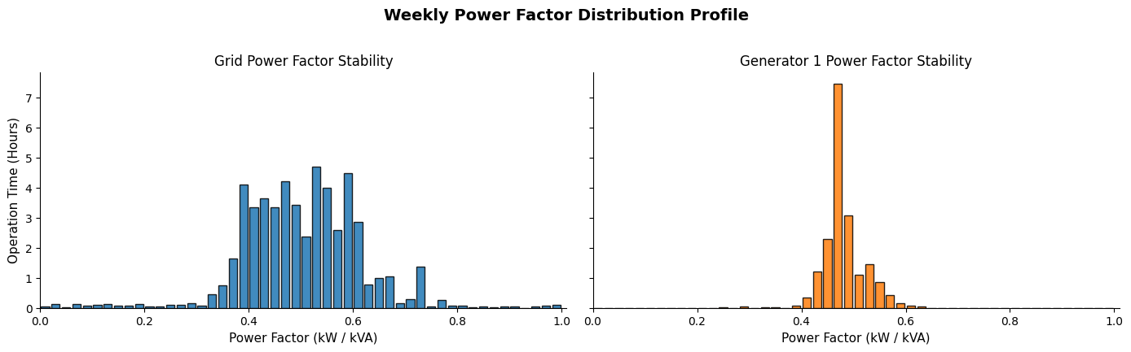
Figure 10: Power factor distribution profile

Power factor does not recover as load rises. It stays within a narrow 0.4 to 0.5 band all the way to the 20 kW peak. The wide scatter at very low load is expected measurement noise, but the persistent low reading at higher load shows the poor power factor is a structural property of the connected equipment rather than an artefact of light loading.
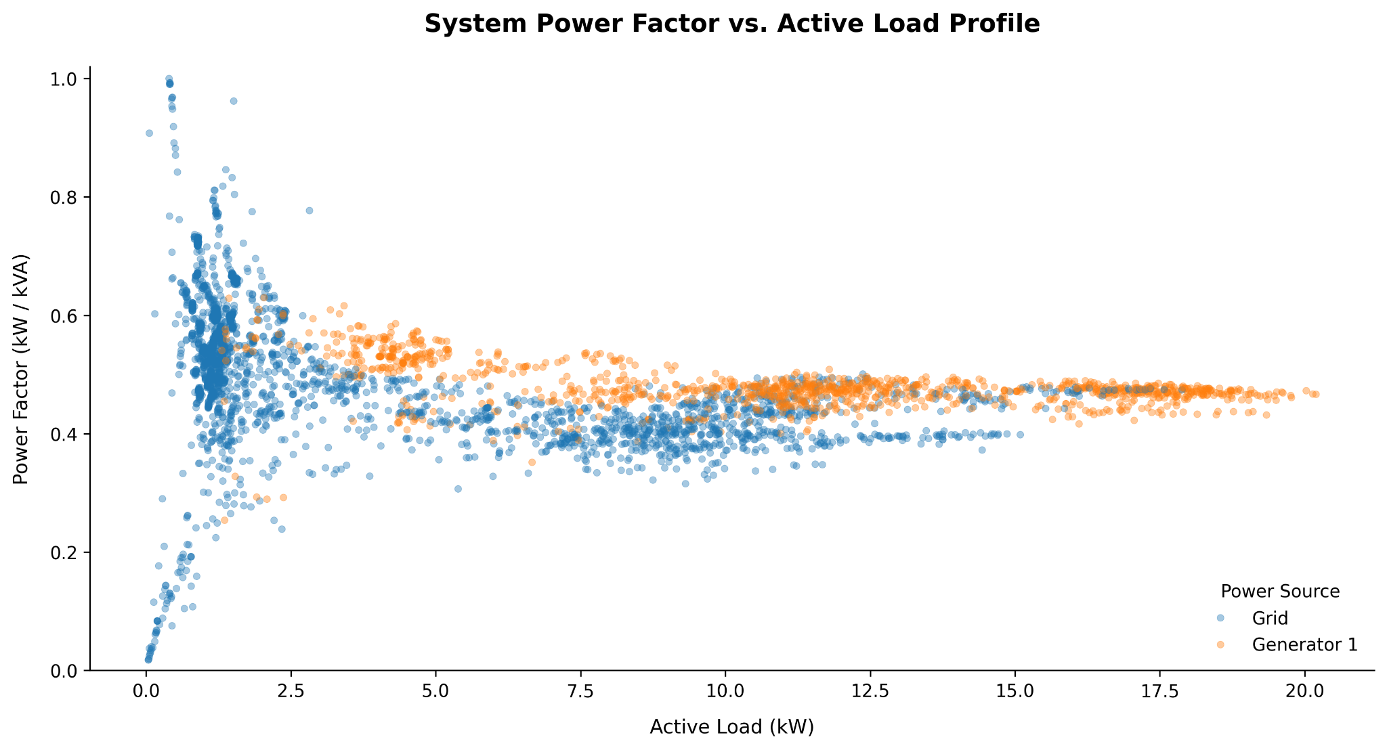
Figure 11: Power factor vs. active load

Current Unbalance
The grid distribution shows a large concentration at about 200%, which corresponds to intervals when only one of the three phases carried current. For the rest of the time both sources ran at more moderate unbalance, with Generator 1 generally tighter than the grid. The frequency and duration of single-phasing are worth a closer look, since prolonged single-phase operation stresses three-phase equipment.
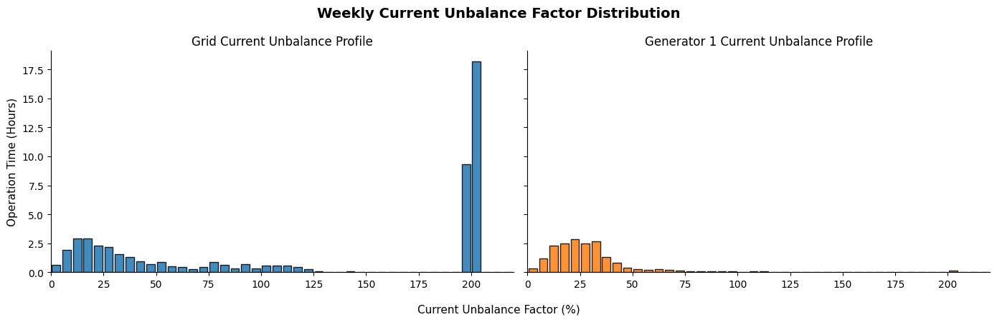
Figure 12: Current unbalance factor distribution
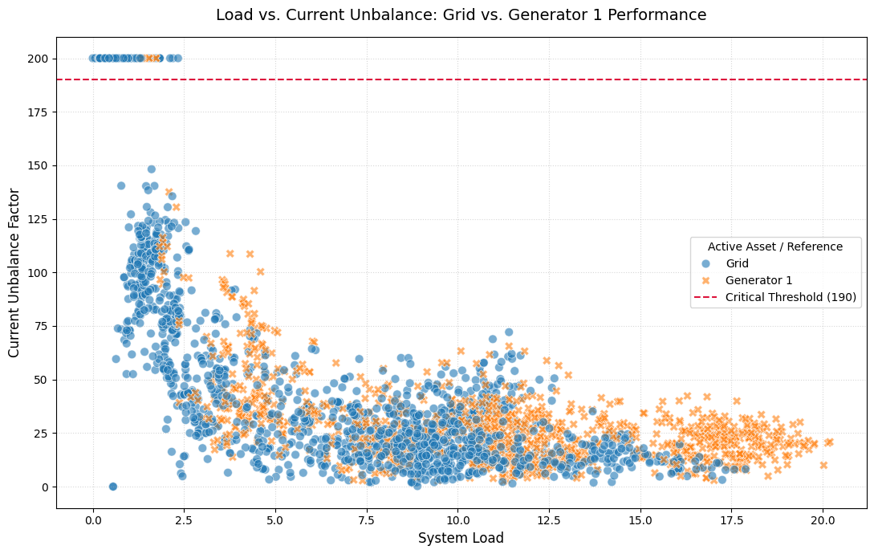
Figure 13: Load vs. Current Unbalance: Grid vs. Generator 1 Performance
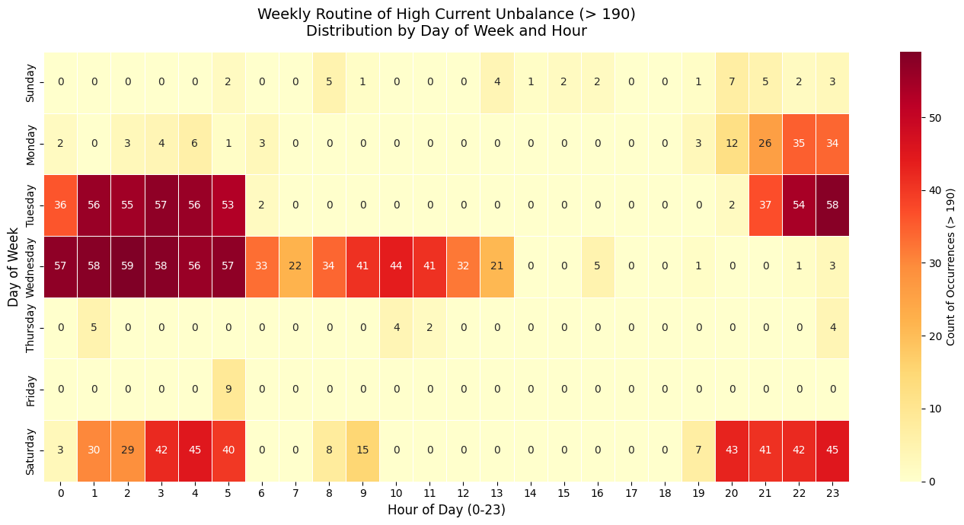
Figure 14: Hourly Distribution of High Current Unbalance (>190%) Occurrences Across the Week
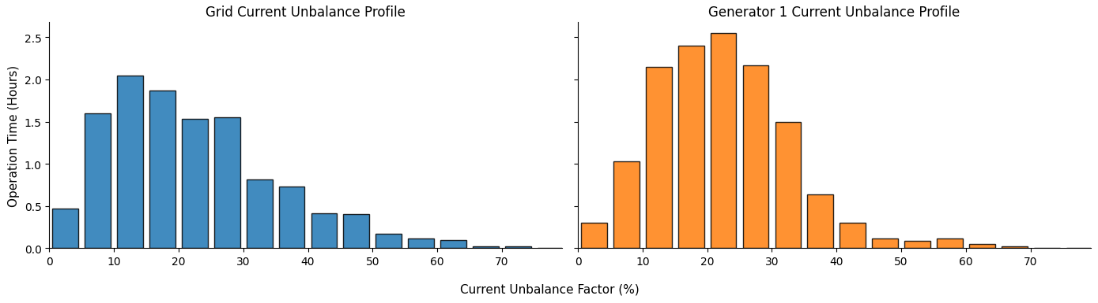
Figure 15: Current unbalance factor distribution during standard working hours (8am - 5pm)

Total Harmonic Distortion (%)
Phase A: 259.33
Phase B: 259.72
Phase C: 1.14
The Phase C value (1.14%) is within a plausible range, while the Phase A and B values (259%) are not physically meaningful and remain under investigation, so no THD chart is presented pending resolution.

Comparison with Former Reports.
- The generator

